Northwind Catalog Application - Complete Documentation

1. Introduction
This project is a full-stack application developed using ASP.NET Core. It uses a layered architecture with Web (MVC), Services (API), and Database (SQL Server).

2. Project Setup Steps
1. Created solution in Visual Studio
2. Added Services project (ASP.NET Core Web API)
3. Added Web project (ASP.NET MVC)
4. Connected both projects using HttpClient
5. Configured SQL Server Northwind database
6. Used Scaffold-DbContext to generate models

3. Database Configuration
Connection string added in appsettings.json.
Used Entity Framework Core (DB First approach).
Tables used: Categories, Products.
Relationship: One Category has many Products.

4. Models Generation
Used command:
dotnet ef dbcontext scaffold ... --table Products --table Categories
Generated Product, Category and DbContext classes.

5. DTO Layer
Created DTOs:
- CategoryDto
- ProductDto
- CategorySummaryDto
Used to transfer data between API and UI.

6. Repository Pattern
Implemented repository pattern to separate data access logic.
Created interfaces and implementations for Category and Product.

7. API Development
Created API Controllers:
- CategoriesApiController
- ProductsApiController
Endpoints:
GET /api/categories
GET /api/products/by-category/{id}
GET /api/products/summary

8. MVC Integration
Used HttpClient in MVC to call API.
Created controllers:
- CategoriesController
- ProductsController
- SummaryController
Views created for displaying data.

9. UI Implementation
Categories shown as cards.
Products shown in table.
Summary shown with analytics (count, avg price, etc.).

10. Unit Testing (xUnit)
Created test project using xUnit.
Tested InventoryValue logic.
Used Arrange-Act-Assert pattern.
Example:
UnitPrice = 10, UnitsInStock = 5 → InventoryValue = 50.

11. Running the Project
Step 1: Run Services (API)
Step 2: Run Web (MVC)
Step 3: Open /Categories
Step 4: Navigate to Products and Summary pages.

12. Conclusion
Successfully developed and tested a full-stack application with API, MVC frontend, and unit testing.

13. Output ScreenShots

Northwind.Tests:
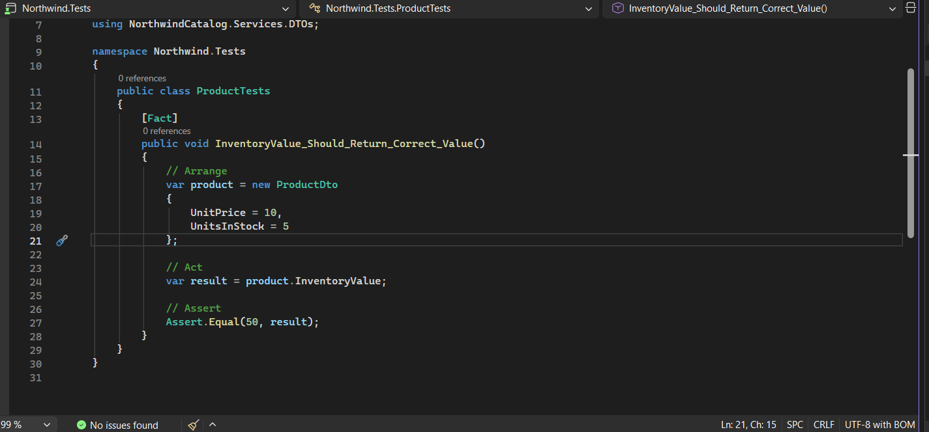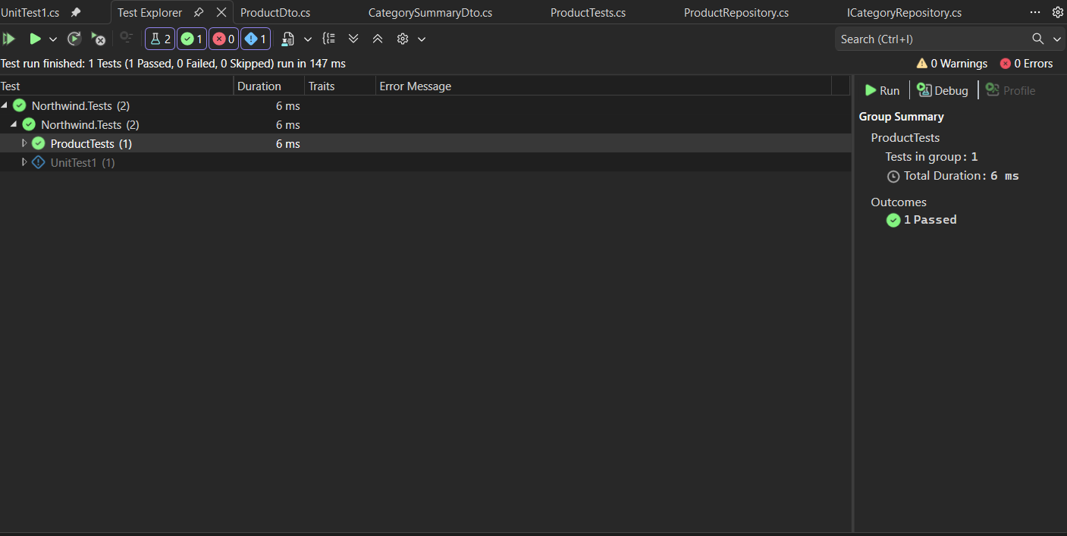

Northwind.Services:
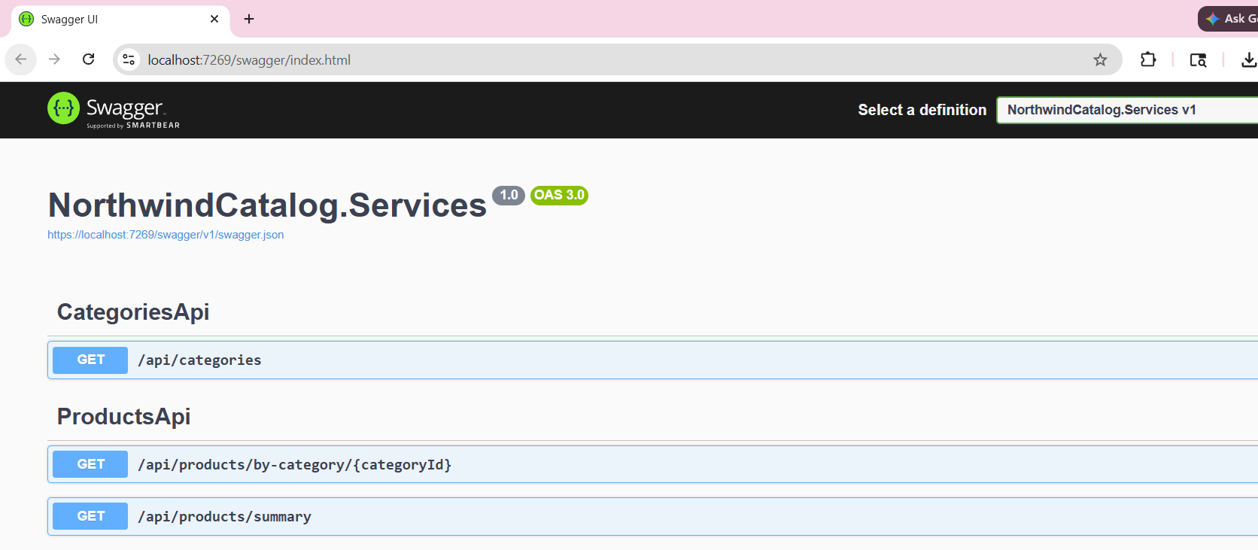Northwind.Web: